**Chapter 1**

**Introduction**

This project addresses the challenge of making numerical data more accessible by converting textual descriptions into structured JSON tables and generating visualizations for immersive exploration. These visualizations are rendered in both Augmented Reality (AR) and Virtual Reality (VR) environments. Traditional 2D graphs often lack depth and engagement, while AR/VR offers spatial understanding and improved perception. The system uses Retrieval-Augmented Generation (RAG) models to identify suitable visualizations from the JSON-formatted data. VR enables basic interactions like zoom, rotate, and pan, whereas AR presents static, view-only visualizations. This chapter sets the context for the project, outlining its scope and objectives, and leads into the subsequent discussion on related work, methodology, implementation, and evaluation.

* 1. **Problem Definition**

Develop a system that transforms textual descriptions of numerical data into suitable visualizations, which are then rendered in an immersive Augmented Reality and Virtual Reality environments for interactive exploration.

* 1. **Motivation**

Traditional 2D visualizations limit depth and spatial context, making complex data harder to interpret. VR and AR offer immersive 3D environments that enhance pattern recognition and insight generation through spatial visualization, making data analysis more intuitive and engaging.

* 1. **Scope of Project and Objectives**

The project aims to develop a system that transforms textual descriptions of numerical data into meaningful visualizations rendered in immersive AR and VR environments. Leveraging Large Language Models (LLMs), Retrieval-Augmented Generation (RAG) models, and 3D rendering, the system overcomes the limitations of traditional 2D visualizations by offering a more spatial and intuitive experience.

**Scope of the Project:**

* **Text-to-Table Conversion:** Use LLMs to extract JSON structured tabular data from textual descriptions.
* **Visualization Identification:** Implement a RAG model to determine the most appropriate visualization type (e.g., bar chart, line chart) from the JSON structured table.
* **3D Visualization Rendering:** Generate and display the visualizations in both VR and AR environments.
* **VR Interaction:** Support basic VR interactions such as zoom, rotate, and pan.
* **AR Visualization:** Provide static, view-only visualization overlays in AR for spatial context.

**Objectives of the Project:**

The primary objectives of this project are:

* To develop a system that converts textual descriptions of numerical data into structured tabular form (in JSON format) using LLMs.
* To design and implement a RAG-based model to identify the most suitable type of visualization (e.g., bar chart, line chart).
* To render 3D visualizations in VR for immersive data exploration with basic interactions like zoom, rotate, and pan.
* To enable static, spatial visualization in AR for passive observation of the data in real-world context.
* To provide a novel approach to data visualization that enhances user understanding and insight generation beyond traditional 2D formats.
  1. **Functional and Non-Functional Requirements**

**Functional Requirements**

* Accept textual description of numerical data as input.
* Convert the textual input into a structured table (JSON format) using LLMs.
* Use a RAG model to identify the appropriate visualization type (e.g., bar chart, line chart).
* Generate 3D visualizations from the structured data.
* Render the visualization in VR with basic interaction (zoom, rotate, pan).
* Display static, view-only visualizations in AR.

**Non-Functional Requirements**

* **Response Time:** The system should convert input and render visualizations in AR/VR within a reasonable time.
* **Accuracy:** The RAG model should consistently identify suitable and meaningful visualizations based on the input data.
  1. **Organization of the Report**

Chapter 1 introduces the problem, motivation, and objectives of the project. It also outlines the scope, describing how textual descriptions of numerical data are converted into 3D visualizations rendered in immersive AR and VR environments. Chapter 2 presents a comprehensive literature survey, reviewing existing work in text-to-table conversion, data visualization techniques, and immersive technologies, and identifies gaps this project aims to address. Chapter 3 outlines the project plan and timeline, detailing phases such as requirement analysis, system design, implementation, and testing. Chapter 4 focuses on implementation, explaining the system architecture, key algorithms, and technologies used — including Large Language Models (LLMs) and Retrieval-Augmented Generation (RAG) models. Chapter 5 discusses results, evaluating the effectiveness of the system in generating visualizations and rendering them in AR and VR, with emphasis on the basic interaction capabilities in VR. Chapter 6 concludes the report by summarizing findings and suggesting future enhancements, such as improving model accuracy and expanding visualization capabilities.

**Chapter 2**

**Literature Survey**

This chapter presents a comprehensive review of existing research that informs the development of the system. The literature survey is divided into three key areas central to the project: Conversion of Text into Table/Images/Videos, Processing Techniques for Text, and Table to Visualization. In the first section, we explore various methods for converting raw text data into structured formats, such as tables, which are necessary for further analysis and visualization. The second section examines advanced text processing techniques, including the use of BERT-based embeddings for text clustering and information extraction, which enable more efficient data structuring. The third section focuses on the challenge of transforming structured data into visualizations, evaluating both LLMs and RAG models for generating suitable visualizations, with a discussion on their limitations and biases. This chapter highlights the gaps in existing research and supports the need for an integrated system that combines text-to-table transformation, semantic text processing, and immersive visualization in AR and VR—where VR allows basic interactions and AR provides static spatial rendering.



**Figure 2.1:** Key areas explored in the Literature Survey

**Conversion of Text into Table/Images/Videos**

This step explores various approaches to transforming raw text data into structured forms, such as tables, images, or videos, that can be used for further analysis or visualization. Several works have explored Large Language Models (LLMs) and sequence-to-sequence (seq2seq) models for generating structured data from unstructured text. These models, such as BERT and GPT, are used to extract key information and organize it into tabular formats, which is critical for downstream visualization tasks.

**Table 2.1:** Summary of Research Papers on Text-to-Table Conversion Methods

| **Year** | **Title** | **Publication (IEEE/Journal)** | **What is the paper about? (Aspects)** | **Methodology (Steps in 2-3 lines)** | **Datasets (Size, Type, etc.)** | **Results (Validation Metrics)** | **Advantages** | **Limitations** | **Ref No.** |
| --- | --- | --- | --- | --- | --- | --- | --- | --- | --- |
| 2024 | Tabularis Revilio: Converting Text to Tables | ACM International Conference on Information and Knowledge Management (CIKM 2024) | This paper introduces Revilio, a system that uses large language models to reconstruct tables from free-form text, especially when column boundaries are lost. It addresses challenges like ensuring semantic and syntactic consistency in table generation. | The system first detects headers from text, generates a table sketch using an LLM, and then refines the table using a "generate-and-rank" strategy to ensure syntactic and semantic consistency. | The paper evaluates Revilio on multiple datasets, including those containing tables with over 100,000 rows. | The system outperforms traditional methods with an accuracy improvement of 5.8–11.3% over neural and symbolic baselines. | It can handle large tables effectively and improves table reconstruction accuracy. | The system is primarily designed for scenarios where table column boundaries are lost and may not generalize well to other types of text-to-table conversion tasks. | [1] |
| 2024 | gTBLS: Generating Tables from Text by Conditional Question Answering | arXiv preprint arXiv:2403.14457 | This paper presents a two-stage approach to converting unstructured text into structured tables. It uses a model that generates table structures (headers) and content by asking questions. | First, the system generates the table structure (headers) from text using conditional text generation. Then, it formulates questions based on these headers and uses an LLM to answer them, filling the table with appropriate content. | The paper evaluates on datasets like E2E, WikiTableText, and WikiBio, among others. | Achieved up to 20% improvement in BERTScores for table content generation tasks compared to previous methods. | The approach ensures syntactically valid tables and can utilize large pre-trained models in a zero-shot configuration, which is beneficial for many real-world applications. | The model requires high-quality training data and fine-tuning to achieve optimal results, which can be resource-intensive. | [2] |
| 2024 | Large Language Models as Generalizable Text-to-Table Systems | Proceedings of the Association for Computational Linguistics (ACL 2024) | This paper explores how large language models (LLMs), such as GPT-3, can be used for the text-to-table task without fine-tuning on specific datasets. It evaluates how LLMs can generalize across various input texts and generate valid tables. | LLMs are prompted to generate tables from unstructured text, and the task is evaluated on multiple datasets using zero-shot and few-shot learning techniques. | Datasets like E2E, WikiTableText, and WikiBio are used for evaluation, focusing on different types of text-to-table conversion tasks. | The approach demonstrates the capability to generalize well across various datasets, with improvements in output quality compared to previous fine-tuned models. | No need for extensive fine-tuning or specific schema design, making it adaptable to various text formats and datasets. | Performance can be inconsistent depending on the complexity and type of text, as LLMs may struggle with non-standard or highly structured data. | [3] |
| 2024 | On the Use of Large Language Models for Table Tasks | VLDB/NeurIPS | Examines how LLMs can generate SQL queries from natural language text using retrieval-augmented generation (RAG). | Implements prompting techniques and fine-tuning on domain-specific tables to improve SQL accuracy. | TabFact, Spider (large-scale tabular question-answering datasets). | Fine-tuned models improve SQL accuracy over zero-shot approaches. | LLMs can generalize across domains. | Requires high computational resources; struggles with complex queries​ | [4] |
| 2022 | Text-to-Table: A New Way of Information Extraction | ACL | Proposes converting unstructured text to structured tables using seq2seq models. | Uses fine-tuned seq2seq models with table constraint and relation embeddings to extract structured data. | Rotowire, E2E, WikiTableText, WikiBio (various sizes, sports, Wikipedia, open-domain tables). | Seq2seq models outperform RE/NER models; BART-large improves extraction accuracy. | No need for predefined schemas; works on long texts. | Struggles with text diversity, reasoning, and large tables​ | [5] |
| 2023 | Towards Controlled Table-to-Text Generation with Scientific Reasoning | IEEE/Scientific NLP Conference | Focuses on controlled text generation from tabular data with a scientific reasoning component. | Introduces CTRLSciTab dataset and uses a retriever-generator model with external domain-specific knowledge. | CTRLSciTab (8,967 table-description pairs with scientific knowledge). | CTRLSciTabNet (Bart) outperforms GPT-3.5, improving fluency and factuality. | Uses domain-specific knowledge for improved accuracy. | Struggles with hallucination and aligning generated text with scientific facts​ | [6] |

**Processing Techniques for Text**

Text processing techniques, including text clustering and information extraction, have been key to understanding how raw text data can be structured. Techniques such as BERT-based embeddings have been applied to text clustering, and various NLP methods have been developed to extract significant data from the text. These processing methods enable more accurate and efficient transformation of text into structured formats (like tables) that are easier to analyze and visualize.

**Table 2.2:** Summary of Research Papers on Text Processing Techniques

| **Year** | **Title** | **Publication (IEEE/Journal)** | **What is the paper about? (Aspects)** | **Methodology (Steps in 2-3 lines)** | **Datasets (Size, Type, etc.)** | **Results (Validation Metrics)** | **Advantages** | **Limitations** | **Ref No.** |
| --- | --- | --- | --- | --- | --- | --- | --- | --- | --- |
| 2023 | FinBERT: A Large Language Model for Extracting Information from Financial Text | Contemporary Accounting Research, Wiley | FinBERT is a domain-specific adaptation of BERT for financial text analysis. It is trained on financial reports, earnings calls, and analyst reports to enhance sentiment classification and financial text understanding. | 1. Pretrained on a large corpus of financial documents (SEC filings, earnings calls, analyst reports). 2. Fine-tuned on sentiment classification and ESG-related discussions. 3. Compared against traditional ML models (SVM, RF, LSTM, CNN) and general BERT. | Financial filings (SEC 10-K, 10-Q), analyst reports, and 136,578 earnings call transcripts. Total dataset size: 4.9 billion tokens. | Achieved 88.2% sentiment classification accuracy (higher than LSTM, CNN, and traditional methods). Outperformed BERT in financial text classification, especially with small training samples. | 1. Improves financial sentiment classification accuracy. 2. Works well with small training datasets. 3. Outperforms traditional ML models and even general BERT for finance applications. | FinBERT, like other deep learning models, lacks interpretability, making its decision process opaque—a key challenge in finance where transparency is crucial. | [7] |
| 2022 | The Performance of BERT as Data Representation of Text Clustering | Journal of Big Data | This paper evaluates the effectiveness of BERT embeddings in text clustering tasks, comparing them with traditional TF-IDF representations. | The study applies BERT to generate text embeddings and compares clustering performance using algorithms like k-means and deep embedded clustering | Utilized three popular text clustering datasets: AG News, DBpedia, and 20 Newsgroups. | BERT-based representations outperformed TF-IDF in 28 out of 36 metrics, including clustering accuracy (ACC), normalized mutual information (NMI), and adjusted rand index (ARI). | BERT captures contextual information, leading to improved clustering performance | The study focuses on unsupervised learning; results may vary with different clustering algorithms. | [8] |
| 2023 | A Survey of Text Representation and Embedding Techniques in NLP | IEEE Access | This survey provides a comprehensive overview of text representation methods in NLP, from early techniques to advanced embeddings. | The paper reviews various text representation techniques, discussing their evolution, applications, and performance in NLP tasks. | Not applicable (survey paper). | Not applicable (survey paper). | Offers a detailed understanding of the progression and applications of text representation techniques. | As a survey, it doesn't provide experimental validations or comparisons. | [9] |
| 2020 | Graph-Based Text Representation and Matching: A Review of the State of the Art and Future Challenges | IEEE Transactions on Knowledge and Data Engineering | This review focuses on graph-based methods for text representation and matching, discussing their applications and future research directions. | The paper analyzes various graph-based text representation techniques, their methodologies, and effectiveness in tasks like text matching and retrieval. | Not applicable (review paper). | Not applicable (review paper). | Highlights the potential of graph-based representations in capturing complex relationships in text. | Lacks experimental comparisons; primarily theoretical analysis. | [10] |
| 2023 | From Text to Knowledge with Graphs: Modelling, Querying and Exploiting Textual Content | arXiv preprint | This paper explores challenges and trends in representing and querying knowledge extracted from text using graph-based models. | The authors discuss integrating linguistics, NLP, and graph databases to transform unstructured text into structured knowledge representations. | Not applicable (conceptual paper). | Not applicable (conceptual paper). | Provides insights into combining multiple disciplines for effective knowledge representation. | Conceptual framework without empirical validation. | [11] |
| 2023 | A Novel Multidimensional Reference Model for Heterogeneous Textual Datasets Using Context, Semantic and Syntactic Clues | arXiv preprint | This study introduces a model to handle heterogeneous textual datasets by leveraging context, semantic, and syntactic information. | The proposed model integrates multiple linguistic features to enhance information extraction from diverse text sources. | Evaluated on datasets with varying sizes and types to test adaptability. | Demonstrated improved extraction of meaningful information across diverse datasets. | Enhances processing of heterogeneous textual data by considering multiple linguistic aspects. | May require complex integration of various linguistic features; scalability needs further assessment. | [12] |

**Table to Visualization**

Once text is converted into a table, the next challenge is transforming that table into a suitable visualization. Text-to-visualization attempts have been made; table-to-visualization can be done using LLMs. However, our findings show that LLMs tend to be biased towards generating specific visualization types, such as pie charts and bar charts, especially when provided with only a few examples. This bias arises from the LLM's inherent tendency to favor these common visualization types, limiting the diversity and appropriateness of the generated visualizations. RAG (Retrieval-Augmented Generation) models are more effective at selecting the most appropriate visualization based on data content. This step is crucial for ensuring meaningful and context-aware visualizations within the immersive AR/VR environments used in this project.

**Outcomes of Background Work:**

**Visual Representation vs Textual Representation:** Research consistently shows that visual representations of data are far easier to interpret than textual data. This highlights the importance of the project's goal of converting text into meaningful visualizations.

**Text Processing:** Various efforts have been made in text processing, particularly in clustering and extracting important data using models like BERT, which have been pivotal in understanding and structuring text data.

**Text to Visualization:** While text-to-visualization techniques are still emerging, models such as LLMs have demonstrated the capability to perform the crucial task of converting tables into visual representations effectively.

**Chapter 3**

**Project Plan and Timeline**

This chapter outlines the structured roadmap adopted for the successful development of the system. It begins with the Project Plan, which breaks the system into modular tasks: from requirement analysis and text-to-table conversion using LLMs, to visualization type selection via RAG models, and immersive visualization rendering in AR and VR. Each stage is defined with its objective and associated technologies. The plan ensures a streamlined development approach that integrates natural language processing, data structuring, and immersive visualization. The second part details the Project Timeline, presenting a task-wise schedule mapped across development phases. A Gantt-style chart illustrates timelines for activities such as requirement gathering, technology selection, LLM testing, dataset preparation, visualization pipeline setup, and AR/VR integration. This structured timeline supports a logical progression and aligns with project deadlines, ensuring on-time delivery.

**Project Plan**

* **Requirement Analysis:** Define system inputs, expected outputs, and confirm data flow.
* **Text-to-Table Module:** Use LLMs to convert textual descriptions into structured tabular data (JSON format).
* **Visualization Selection:** Apply a RAG model to determine the most appropriate chart type based on data content.
* **3D Visualization Rendering:** Convert selected visualization types into 3D models and render them in AR and VR environments.
* **VR Interaction:** Enable basic controls like zoom, rotate, and pan for immersive data exploration.
* **AR Visualization:** Display static, spatial visualizations in AR for passive viewing.
* **System Integration and Testing:** Combine all modules and verify overall functionality, performance, and visual accuracy.

**Project Timeline**

The Gantt chart titled "Project Timeline with Task-wise Breakdown and Scheduled Dates" outlines the end-to-end phases from January to April 2025. It is divided into four main sections:

**1. Planning (mid-January):** Covered initial project planning and requirement gathering.

**2. Research & Tech Setup (late January to mid-February):** Focused on studying research papers, finalizing the tech stack, and selecting a suitable LLM model.

**3. Testing Phase (late February to early March):** Involved testing the LLM with sample inputs and documenting the results.

**4. Implementation (March to April):** Included tasks such as converting text to tables, developing the VR environment, dataset creation, building a RAG model for visualization, developing AR visualization, and finally integrating all components.

Each task is time-boxed, and completed phases are visually marked, showing steady progress toward project completion.

**Table 3.1:** Project Timeline with Task-wise Breakdown and Scheduled Dates

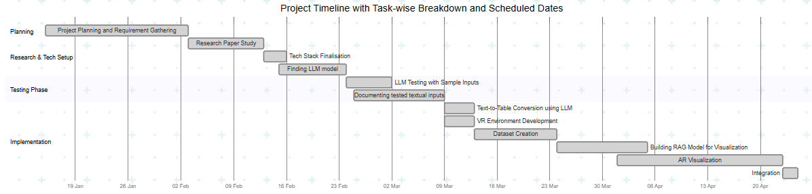

**Chapter 4**

**Implementation**

This section details the end-to-end system implementation for converting user-submitted textual descriptions of numerical data into immersive 3D VR and AR visualizations. It starts with a description of the frontend interface, where users input their data in natural language and choose between three options—VR generation, chart generation via a RAG model, or AR visualization. The process continues with input validation to ensure the presence of meaningful numerical content. Valid input is then passed to a Large Language Model (LLM) to extract structured tabular data. This structured data is further processed by a RAG model trained on sector-specific datasets to determine the most appropriate visualization type. The selected chart is rendered in a 3D VR environment using Unity and Three.js, offering zoom functionality for deeper insight. Additionally, the same chart can be rendered in an AR environment using Unity and AR Foundation, allowing users to place and explore data visualizations in their real-world surroundings. This chapter highlights how each technology—LLMs, RAG models, Unity, and AR/VR frameworks—contributes to transforming raw textual input into an engaging, spatially interactive experience.

4.1 **Architecture / Block Diagram**



**Figure 4.1:** Workflow for Textual Data to VR Visualization

4.2 **Algorithm / Methodology**

1. **Frontend Interface**  
   The process begins with a simple and intuitive frontend interface designed to accept a textual description of numerical data from the user.

The interface contains a text input box, where the user can enter natural language input like:  
I have 100 Rs. I spent 20 on clothes, 10 on food.

Below the input box, there are three action buttons:

* 1. Generate VR – Initiates the generation of a Virtual Reality-based 3D visualization.
  2. Generate Visualisation Chart – Uses a Retrieval-Augmented Generation model to process the table achieved from the LLM model and generate a visualisation chart.
  3. Generate AR – Produces an Augmented Reality visualization for mobile

1. **Input Validation**

Once the form is submitted, the system performs validation on the entered text:

* + It checks that the input falls within an acceptable word limit, ensuring it's neither too short to lack meaning nor too long to overwhelm the model
  + It confirms the presence of numerical data—quantities, percentages, counts, or monetary figures—necessary for further processing. If the input fails either check, the system alerts the user and prompts them to revise and resubmit the input.

1. **Text Parsing into Structured Tabular Format Using LLM**
   * For valid input, the text is passed to a Large Language Model (LLM) that processes the natural language and extracts structured data.
   * The LLM identifies key attributes (e.g. years, counts, ratios, and categories), and organizes them into a table.
2. **Chart Type Selection Using a RAG Model**
   * The structured table is then passed into a Retrieval-Augmented Generation (RAG) model.
   * This model is trained on a custom dataset of 50 records from the education, agriculture, environment, commerce and finance sectors (sourced from[community.data.gov.in](http://community.data.gov.in)), helping it identify contextually appropriate visualization types.
   * Depending on the tabular content, the RAG model selects a 3D visualization type such as bar chart or line graph.
3. **3D VR Visualization Rendering Using Unity and Three.js**Based on the selected visualization type, the system uses Unity and Three.js to render a 3D chart in a Virtual Reality environment. Inside the VR environment, users can interact with the visualization to enhance their understanding. Interaction features include Zooming In/Out to closely inspect specific data points or get a full overview.
4. **Completion and Insight Extraction**
   * Once the interactive 3D visualization is rendered, users can explore the data in an immersive environment.
   * The process concludes with the user gaining clear, intuitive insights from their original textual input—bridging the gap between raw data and visual understanding without manual chart creation.

7. **3D AR Visualization Rendering Using Unity and AR Foundation**

* + Once the chart is generated, Unity and AR Foundation are used to build a 3D chart, which is rendered in an Augmented Reality environment on the user’s Android device. The AR experience includes Color-coded X, Y, and Z axes, labeled using TextMeshPro and Chart geometry (bars, lines) built using Unity primitives.
  + The AR-based 3D chart helps users better understand data by placing it in their real-world environment. With clearly labeled, color-coded axes and 3D shapes like bars or lines, users can easily see patterns and relationships. Displaying data in space makes complex information more intuitive and visually engaging, especially for presentations or learning.

4.3 **Technology used**

**Unity (2023.1.0)**

Used to create the Augmented Reality (AR) environment and render 3D visualizations. It enables immersive viewing of the visualized data within the AR space.

**Python (3.10)**

Acts as the backbone for data processing, handling input/output flow, and managing API integration between various components of the system, including the LLM and visualization modules.

**Large Language Models (LLMs)**

Responsible for converting unstructured textual input into structured tabular data. The LLM extracts entities, numerical values, and contextual information to form a usable dataset.

**Retrieval-Augmented Generation (RAG) Model**

Analyzes the structure and semantics of the tabular data to determine the most suitable type of data visualization, such as bar charts or line graphs.

**Chapter 5**

**Results and Discussion**

The developed system successfully converts textual descriptions of numerical data into structured tabular format in JSON using Large Language Models (LLMs). A custom dataset was created to train the Retrieval-Augmented Generation (RAG) model, enhancing its ability to map the JSON-formatted data to the most relevant visualization type, such as a bar chart or line chart. These visualizations are then rendered as 3D models for immersive viewing in both Virtual Reality (VR) and Augmented Reality (AR). While VR supports basic interaction through zooming, rotating, and panning, AR provides static spatial placement for passive observation. This section evaluates the system’s performance across each stage, highlighting its effectiveness, accuracy, and observed limitations.

**Key findings:**

The system efficiently translates textual descriptions of numerical data into structured JSON tables using the Llama-2-13B-chat.Q4_K_M model.

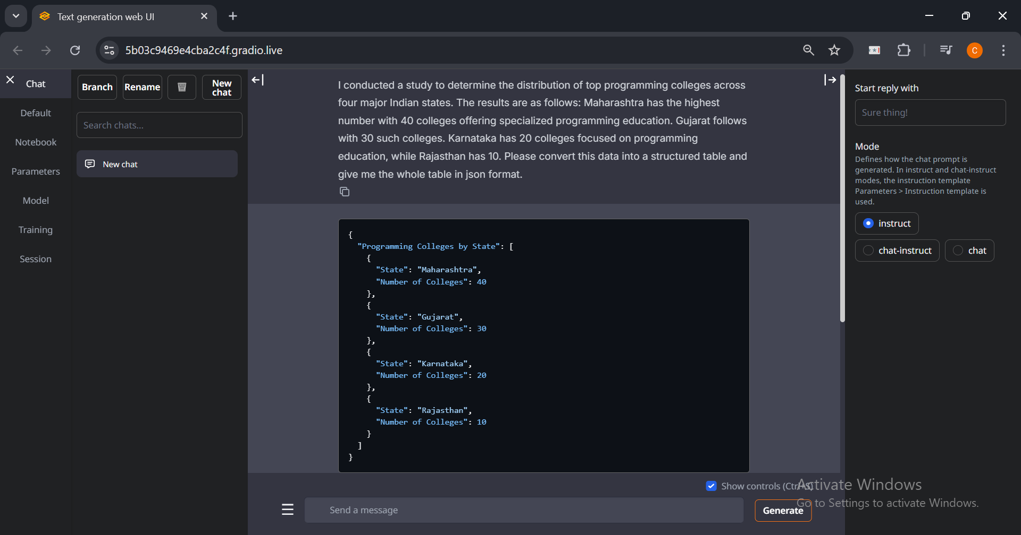

**Figure 5.1:** Converting text into structured tables using LLM (Llama-2-13B-chat.Q4_K_M)

A custom dataset of 50 records was created to train the RAG model, improving its ability to map structured tabular data to the most relevant visualization type.

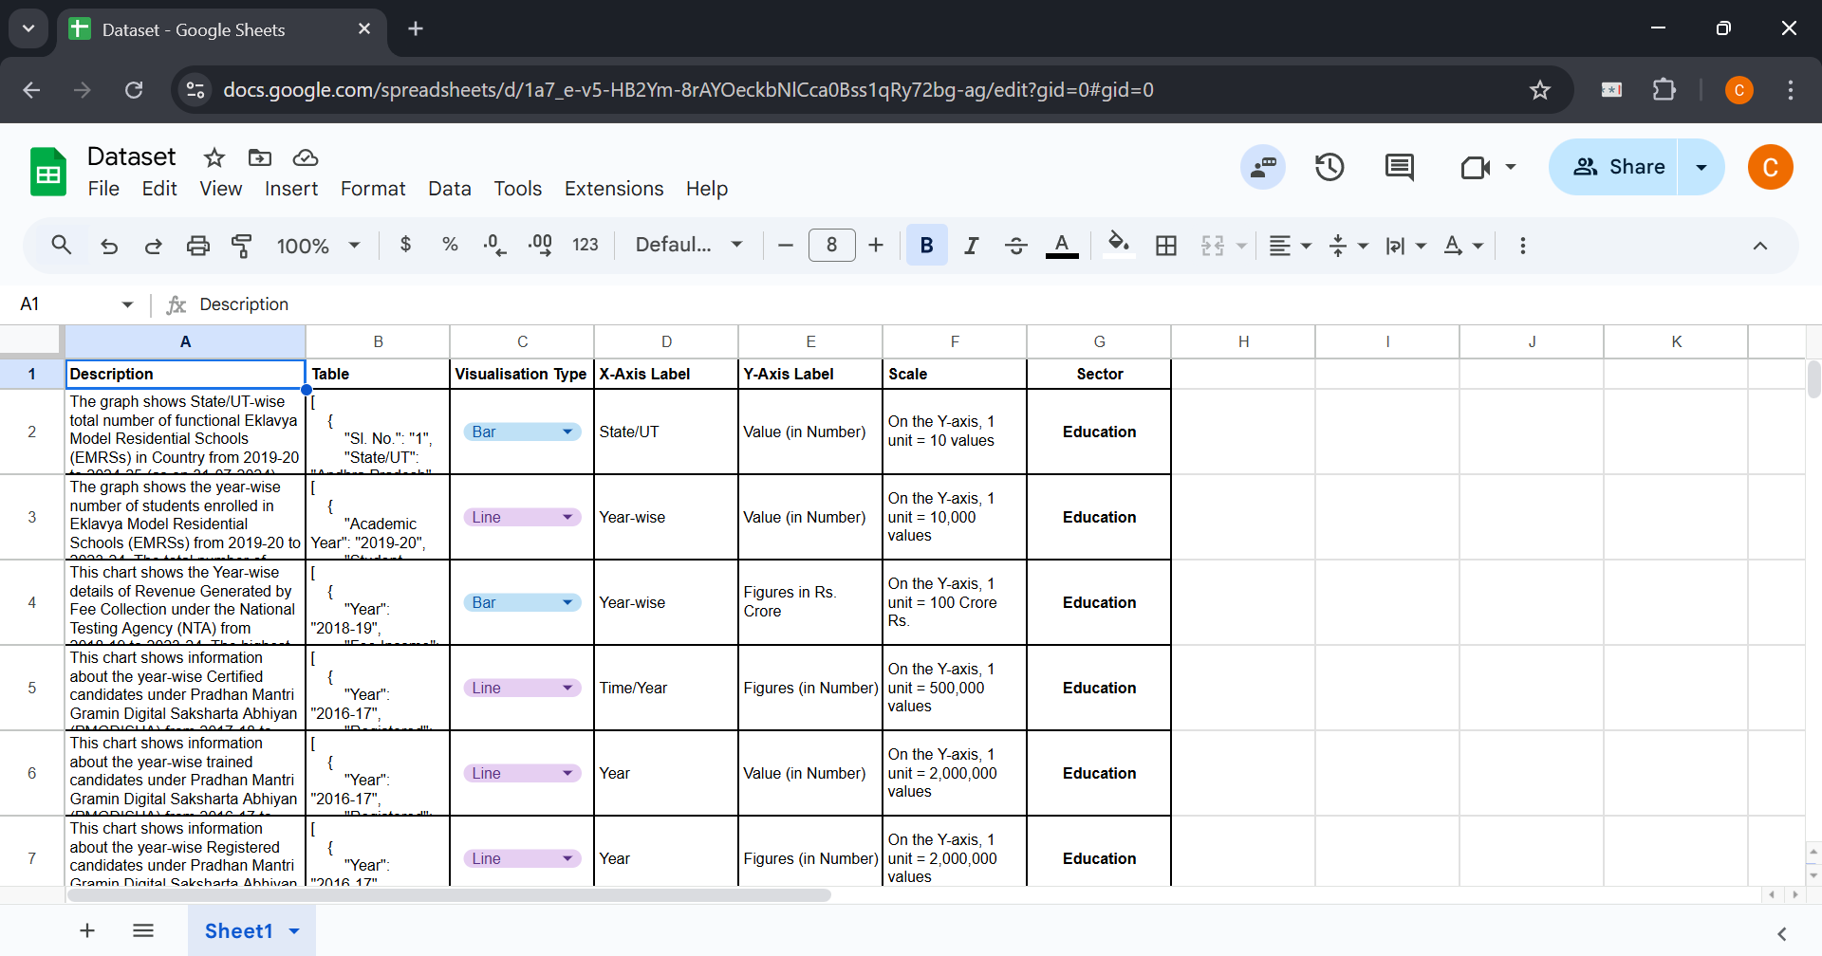

**Figure 5.2:** Custom dataset for RAG model training

The RAG model effectively predicts the most appropriate visualization type based on the nature and distribution of the tabular data.

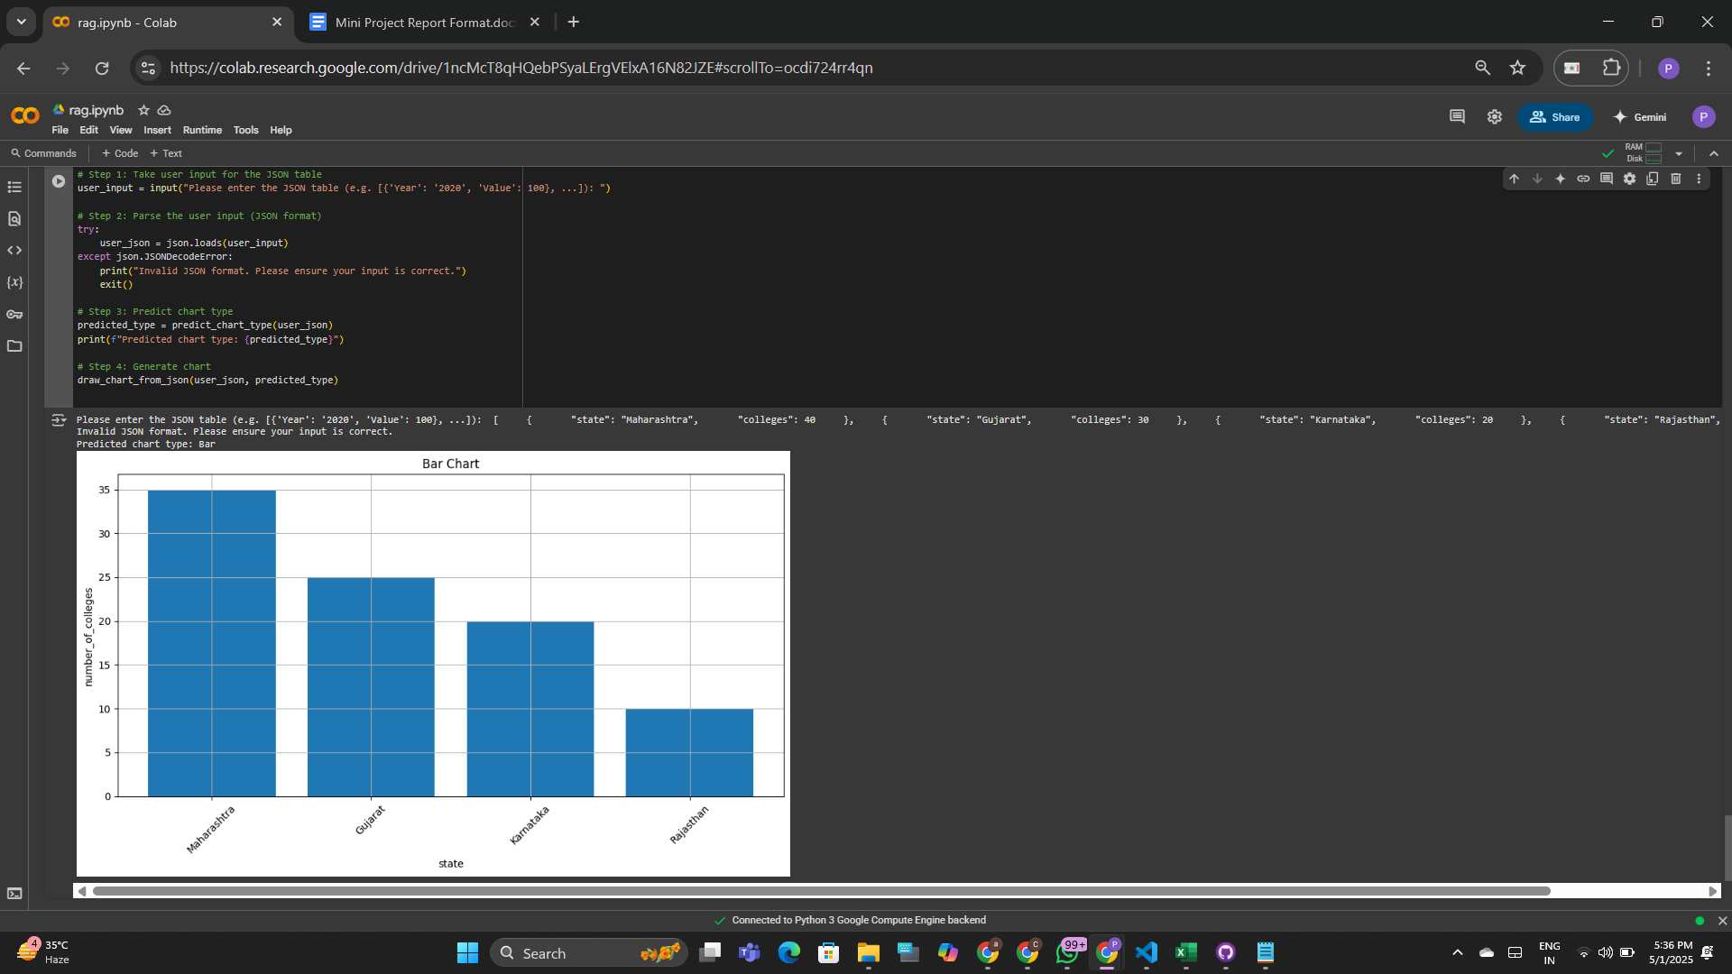

**Figure 5.3:** Visualization type prediction by RAG model based on input JSON data

The system renders the selected visualizations as immersive 3D models in both Virtual Reality (VR) and Augmented Reality (AR). In VR, users can zoom, rotate, and pan to explore the visualization. In AR, the charts are displayed as static 3D objects within the camera view.

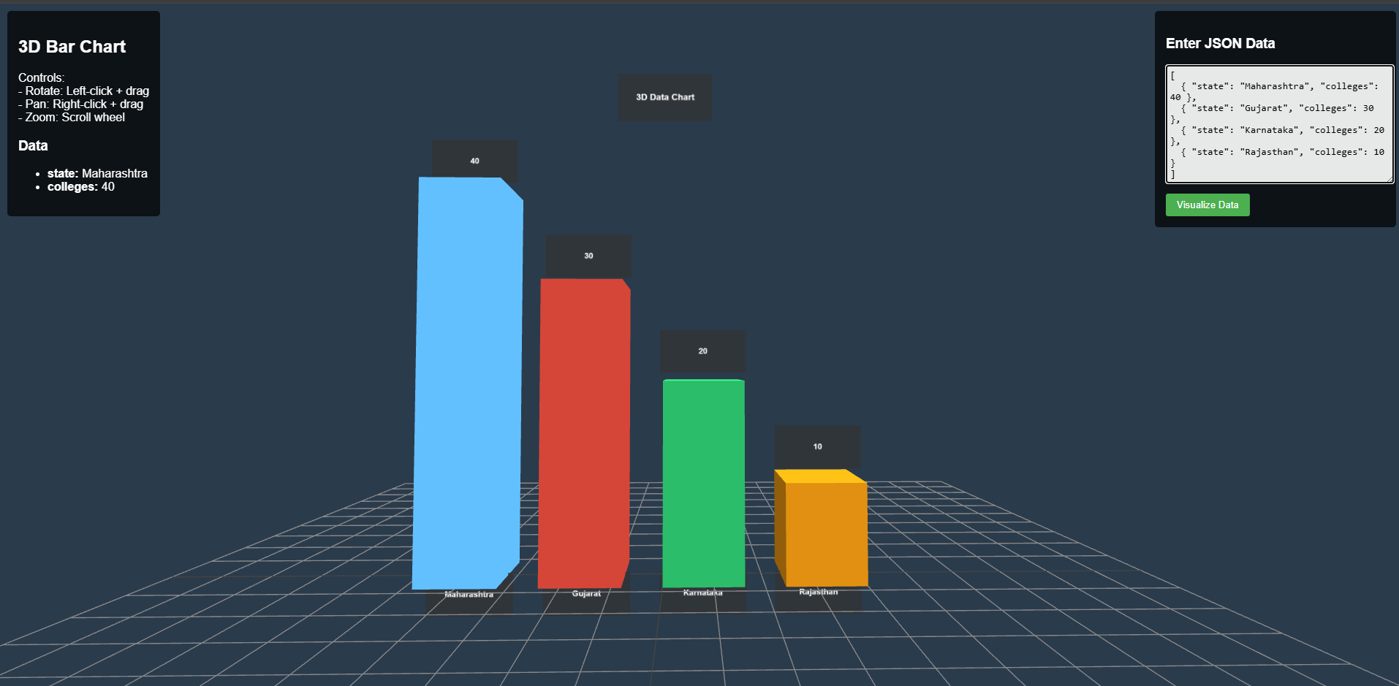

**Figure 5.4:** VR environment displaying a 3D visualization generated from JSON input

The AR visualization displays a 3D bar chart comparing the number of colleges across four Indian states. Each bar is color-coded and positioned in real-world space, enhancing clarity and engagement through spatial data representation.

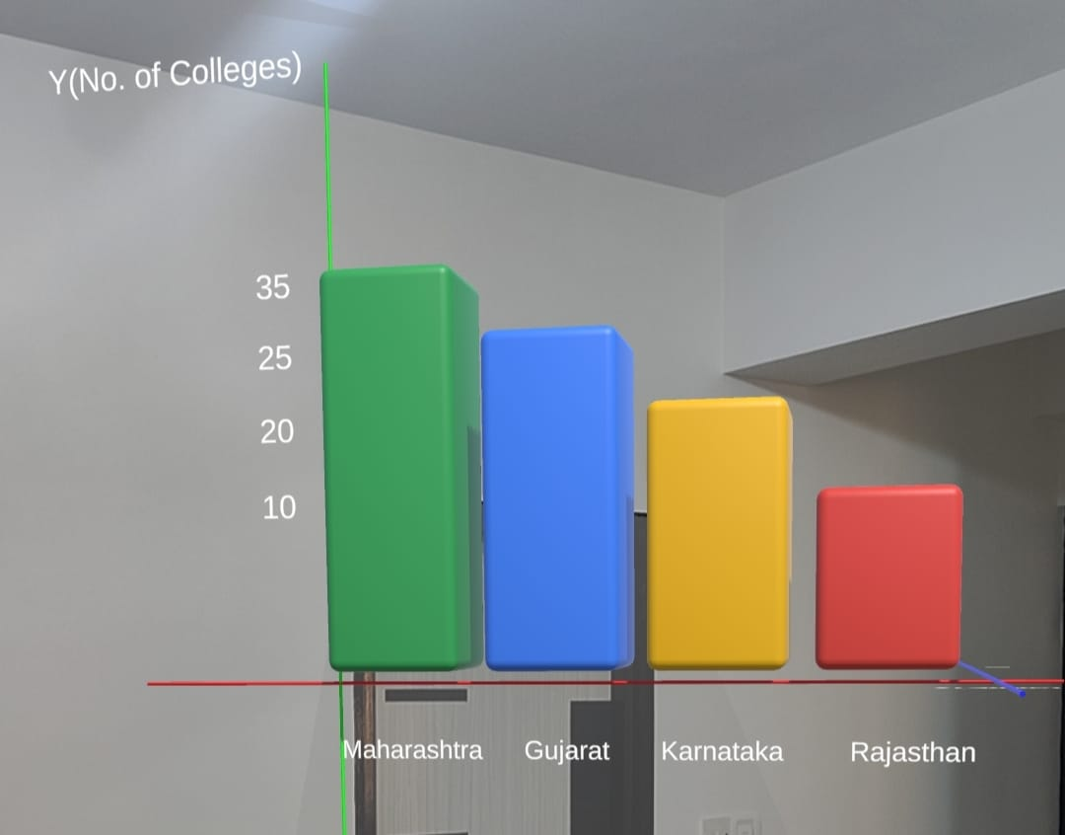

**Figure 5.5:** AR environment displaying a static 3D visualization

**Performance Evaluation**

* **Text-to-Table Conversion (LLM):** The Llama-2-13B-chat.Q4_K_M model achieved a **100% JSON validity rate**, ensuring that all outputs were syntactically correct. It demonstrated a **94% accuracy in field extraction**, correctly identifying the expected keys from the input text, and a **91% accuracy in value extraction**, accurately mapping the numerical values to their respective fields in the generated JSON.
* **Visualization Type Prediction (RAG Model):** The RAG model, trained on a custom dataset of 50 labeled samples, demonstrated progressive improvement across 15 epochs. It began with a baseline validation accuracy of 44.44% and gradually improved to a peak of 88.89%. The model consistently reduced its loss from 0.6931 to 0.6168, indicating effective learning. This training progression reflects the model's increasing ability to generalize from limited data, ultimately achieving **88.89% classification accuracy** on the validation set by the final epoch.
* **VR Visualization Rendering:** The system was deployed on Meta Quest 2, where the visualizations were displayed in a stable and responsive panel within the VR interface. The environment effectively demonstrated key functionalities such as zoom, pan, and rotation, with smooth performance and **interaction latency under 100 milliseconds**. The visualization panel loaded promptly, with an **average scene load time of 1.5 seconds**, providing a functional and user-friendly VR experience for data exploration.
* **AR Visualization Rendering:** In the AR mode, the system displayed floating 3D visualizations within the camera view. This setup provided a lightweight and platform-independent approach to visualizing data in augmented environments.

**Chapter 6**

**Conclusion and Future Work**

This chapter concludes the report by summarizing the key findings and outcomes of the project. It highlights how the system has successfully implemented a unified system capable of transforming natural language descriptions of numerical data into both VR and AR-based 3D visualizations. The system integrates a frontend user interface, a Large Language Model (LLM) for parsing text to structured JSON tables, a Retrieval-Augmented Generation (RAG) model for chart type selection, and rendering tools like Unity, Three.js, and AR Foundation for immersive visual output. By supporting both VR and AR modes, the solution enables users to intuitively explore their data in simulated and real-world environments. The use of color-coded axes, interactive 3D elements, and smart chart selection has made complex data more accessible and engaging. This project not only demonstrates the feasibility of bridging textual input with immersive data representation but also sets a foundation for more adaptive and intelligent visualization systems.

6.1 **Conclusions**

This project successfully demonstrated the feasibility of generating both VR and AR visualizations from textual descriptions of numerical data. By integrating Large Language Models (LLMs), a Retrieval-Augmented Generation (RAG) model, and immersive technologies like Unity, Three.js, and AR Foundation, the system provides a seamless pipeline from natural language input to interactive 3D chart rendering.

Key achievements include:

* Efficient parsing of textual descriptions into structured tabular formats using LLMs.
* Accurate selection of appropriate visualization types through a custom-trained RAG model.
* Enhanced data understanding via immersive 3D experiences in both virtual and augmented environments.
* Versatile application potential across domains such as education, agriculture, commerce, and environmental analytics.

While the system meets its core objectives, limitations such as limited dataset diversity, platform dependency, and scope for broader interaction design point to opportunities for future refinement and extension.

6.2 **Scope for Future Work**

Future enhancements to the project could include:

* **Multimodal Input Support**: Enabling support for voice input or scanned handwritten descriptions to broaden accessibility.
* **Dynamic Dataset Expansion**: Training the RAG model on a larger and more diverse dataset across multiple domains to improve generalization and accuracy.
* **Live Data Integration**: Allowing the system to connect with APIs and databases for real-time chart updates based on incoming data streams.
* **Advanced AR/VR Interactions**: Introducing gesture-based manipulation, voice commands, or gaze tracking to create a more natural and immersive user experience.
* **Cross-Device Compatibility**: Extending visualization support across different platforms such as iOS, desktop browsers (via WebXR), and VR headsets.
* **Model Optimization**: Reducing latency in visualization rendering and improving the efficiency of LLM and RAG model inference time for real-time performance.
* **Multilingual Processing**: Incorporating multilingual understanding to process user inputs in regional or global languages, enhancing accessibility.
* **User Customization Features**: Allowing users to choose color schemes, axis scales, or data filters to personalize the visualization output.

These improvements would strengthen the system’s practical applications and usability in real-world scenarios.

**References**

1. S. Coyne and Y. Dong, "Tabularis Revilio: Converting Text to Tables," ACM International Conference on Information and Knowledge Management (CIKM 2024), 2024.
2. M. Singh, S. Gulwani, V. Le, and G. Verbruggen, "gTBLS: Generating Tables from Text by Conditional Question Answering," arXiv preprint arXiv:2403.14457, 2024.
3. A. Sundar, C. Richardson, and L. Heck, "Large Language Models as Generalizable Text-to-Table Systems," Proceedings of the Association for Computational Linguistics (ACL 2024), 2024.
4. Y. Dong, M. Oyamada, C. Xiao, and H. Zhang, "On the Use of Large Language Models for Table Tasks," VLDB/NeurIPS, 2024.
5. X. Wu, J. Zhang, and H. Li, "Text-to-Table: A New Way of Information Extraction," ACL, 2022.
6. Z. Guo, J. Zhou, J. Qi, M. Yan, Z. He, X. Wang, and C. Zhou, "Towards Controlled Table-to-Text Generation with Scientific Reasoning," IEEE/Scientific NLP Conference, 2023.
7. A. H. Huang, H. Wang, and Y. Yang, "FinBERT: A Large Language Model for Extracting Information from Financial Text," Contemporary Accounting Research, vol. 40, no. 2, pp. 806–841, Summer 2023, doi: 10.1111/1911-3846.12832.
8. P. Kumar, R. Kumar, and A. Gupta, "The Performance of BERT as Data Representation of Text Clustering," Journal of Big Data, 2022.
9. T. A. Sharma, R. P. Singh, and K. Gupta, "A Survey of Text Representation and Embedding Techniques in NLP," IEEE Access, 2023.
10. R. Kumar and A. Gupta, "Graph-Based Text Representation and Matching: A Review of the State of the Art and Future Challenges," IEEE Transactions on Knowledge and Data Engineering, 2020.
11. A. Sharma, R. Patel, and R. Singh, "From Text to Knowledge with Graphs: Modelling, Querying and Exploiting Textual Content," arXiv preprint, 2023.
12. D. Patel and M. Kumar, "A Novel Multidimensional Reference Model for Heterogeneous Textual Datasets Using Context, Semantic and Syntactic Clues," arXiv preprint, 2023.

**Acknowledgements**

We, the members of the project team, Chandana Galgali, Prachi Gandhi, Mahek Thakkar and Harsh Singwi, would like to express our sincere gratitude to all those who contributed to the successful completion of this mini project.

Firstly, we would like to extend our deepest appreciation to our Project Guide, Prof. Avani Sakhapara, for her unwavering guidance, continuous support, and valuable feedback throughout the project. Her expertise and insightful suggestions were instrumental in shaping our approach and ensuring the project’s success.

We are also grateful to the IT Department and the ETRX Department at KJSSE for providing the necessary resources, facilities, and an enabling environment that made the completion of this project possible.

Finally, we would like to express our heartfelt thanks to our families and friends for their constant support, encouragement, and understanding. Their moral support and patience were crucial in helping us navigate the challenges of this project.